FLASCA BEFORE SCHOOL PROGRAM: TERM 1 WEEK 1
OUTCOME 1: CHILDREN HAVE A STRONG SENSE OF IDENTITY
OUTCOME 2: CHILDREN ARE CONNECTED WITH AND CONTRIBUTE TO THEIR WORLD
OUTCOME 3: CHILDREN HAVE A STRONG SENSE OF WELLBEING
OUTCOME 4: CHILDREN ARE CONFIDENT AND INVOLVED LEARNERS
OUTCOME 5: CHILDREN ARE EFFECTIVE COMMUNICATORS


 | MONDAY | TUESDAY | WEDNESDAY | THURSDAY | FRIDAY
BREAKFAST CLUB |  |  |  | LEARNING OUTCOME:  OUTCOME 3+4    ACTIVITY: FRUIT SMOOTHIES | LEARNING OUTCOME:  OUTCOME 3+4    ACTIVITY: WAFFLES OR PANCAKES  
ACTIVITY 1 (7:00AM – 8:45AM) | VACATION  CARE | VACATION  CARE | VACATION  CARE | LEARNING OUTCOME: OUTCOME 4  ACTIVITY: HAMA BEADS   | LEARNING OUTCOME:  OUTCOME 3+4  ACTIVITY: RELAXING DRAWING  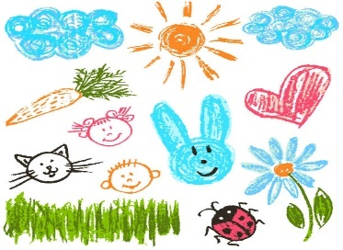
ACTIVITY 2  (8:45AM – 9:00AM) |  |  |  | LEARNING OUTCOME:  OUTCOME 3+4+5    ACTIVITY: CHILDREN’S CHOICE (BRAINBREAK, STORYTIME, BEHIND THE NEWS). | LEARNING OUTCOME:  OUTCOME 3+4+5    ACTIVITY: CHILDREN’S CHOICE (BRAINBREAK, STORYTIME, BEHIND THE NEWS).

